HOW TO RENEW LIBRARY BOOKS ONLINE?

If you know how to renew books online, click here to start renewal, otherwise, please read the instruction .
INSTRUCTIONS
It is very convenient to renew books which have been borrowed by you. This can be done online from anywhere, irrespective of whether you are inside or outside the campus. Faculty members, and FP students are allowed to renew books online three (3) times. PGP, PGPEX, VLMP and PGDBA students are allowed to renew books online once.
Following is the process for renewal:
- Go to the online catalog and click on “log in”

- User the membership number given on your library card as user-id and password.

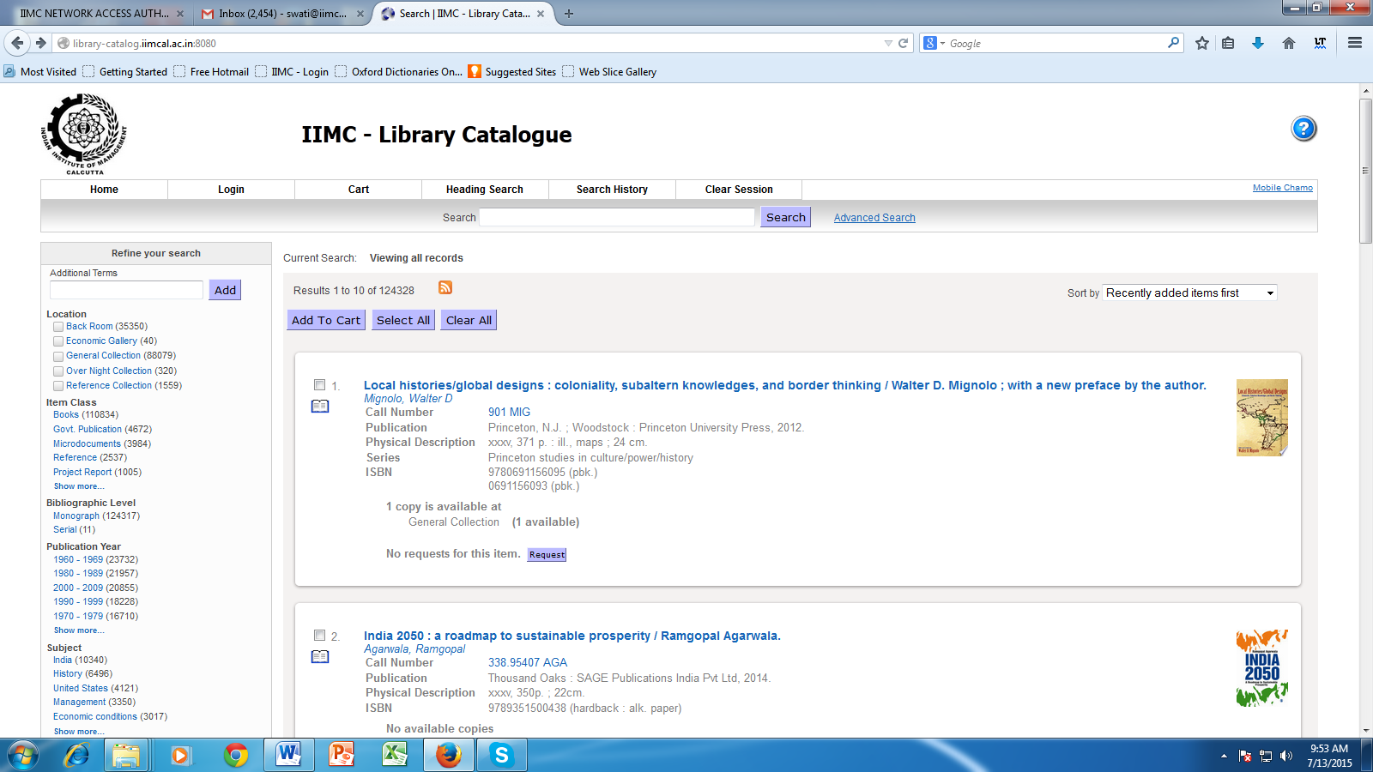

- Click on “My Account” on the upper bar.

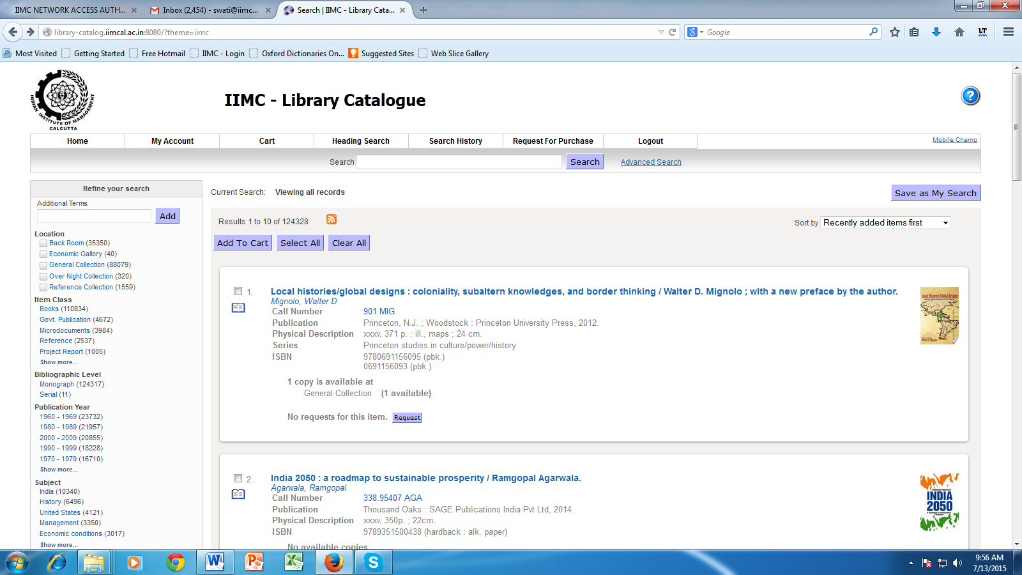

- Select the book that you want to renew online and click on the “Renew” button.

